**Project Proposal**

**Project Name, Participants, and Workflow**

**Project Name:** Ocular Disease Classification using Image Recognition

|  |  |  |
| --- | --- | --- |
| **Participant** | **Email** | **Role** |
| Neda Langroodi | nedalangroodi@my.unt.edu | Research topic background; Resources and related projects; Team member to contribute to overall project according to discussed project plan |
| Bijesh Patel  Vachanni | bijeshpatelvachanni@my.unt.ed u | Structuring project  methodology and design; Team member to contribute to overall project according to discussed project plan |
| Mica Haney | micahaney@my.unt.edu | Team member to contribute to overall project according to discussed project plan |

A Discord chat has been created so the team can quickly and effectively communicate with each other. Team meetings will be held outside of class using its calling capabilities. We will use a collaborative google colab project for development on the model and google docs for documentation so that team members can access the same document and access version control as necessary.

**1**

**Workflow:**

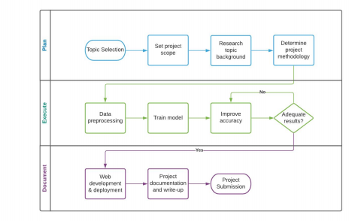

**Project Abstract**

Ocular disease is an umbrella term that is used to refer to any condition that affects the eye and its ability to function properly. There are several different forms that could take place, from cataracts to diabetic retinopathy and glaucoma. Typically, in order to detect if an individual has one of these diseases, an eye examination needs to take place. This

could involve a vision test, dilating the eyes, and getting imaging tests of the entire eye (see Figure 1), which includes the retina, optic nerve, macula, and blood vessels. These images then need to be assessed by a professional to try to target the key issue that is causing eye problems.

This analysis will train and deploy a machine learning model that can quickly classify a digital imaging test to identify the most likely ocular disease. Image classification will be used to determine if an eye image falls under one of the categories: a healthy eye, diabetic retinopathy, glaucoma, cataract, age related macular degeneration, hypertension, pathological myopia, and other diseases. This model will serve as a tool that can be used during digital imaging to give the medical professional a lead of what

**2**

the eye test looks like based on historical images, which can give confidence to the final diagnosis and treatment plan.

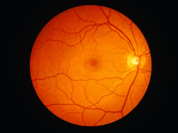

**Fig1. Example of digital imaging test of a healthy eye**

**Project Design Milestones**

**Project Design:**

Our team is going to develop a deep learning model to detect the ocular eye disease using Convolution Neural Networks. We will use the data set from Kaggle website which has Ocular Disease Intelligent Recognition (ODIR) a structured ophthalmic database of 5,000 patients with age, color fundus photographs from left and right eyes and doctors' diagnostic keywords from doctors. Dataset is annotated with eight labels: Normal(N), Diabetes (D), Glaucoma (G), Cataract (C), Age related Macular Degeneration (A), Hypertension (H), Pathological Myopia (M), Other diseases/abnormalities (O). We will perform data preprocessing to resize the images in a dataset which will give high accuracy metrics. We will define Convolution Neural Networks architecture for training the model. Using training and test loss we will build a confusion matrix to evaluate the model's performance on test data.

List of technologies:

● Flask Framework

● Python

● Keras

● Tensorflow

● Google Colab

**3**

● Visual Studio

● Github

**Milestones:**

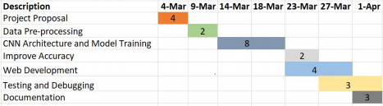**Fig2. Gantt Chart of Ocular Disease Detection using Image Recognition**

**Resources and Related Projects**

**Resources:**

● https://www.firsteyecaredfw.com/services/ocular-diseases/

This resource will aid us in getting more insight on ocular diseases and their potential diagnosis/treatment routes.

● https://indatalabs.com/blog/ai-face-recognition-in-healthcare

This resource explains how face recognition and artificial intelligence (AI) are being used to further the healthcare industry. This source will assist in understanding how related projects are moving the healthcare industry forward.

● https://www.kaggle.com/andrewmvd/ocular-disease-recognition-odir5k This Kaggle site holds the data set and initial topic inspiration for this project. In addition to this, the discussion section can be referenced to identify any issues other Kaggle users have encountered and assess our model’s performance. This Kaggle data set is an open source that is available for distribution with proper credit to Shanggong Medical Technology Co. for data collection and database creation.

● https://www.nih.gov/news-events/nih-research-matters/artificial-intelligence-enha nces-mri-scans

**4**

This source gives insight into related healthcare projects that used machine learning to improve healthcare tools such as MRI scanners.

● https://www.nwhillseyecare.com/services/ocular-disease/

This is an informational resource from the Northwest Hills Eye Care Clinic. This will contribute to a better understanding of different forms of ocular disease.

● https://www.researchgate.net/profile/Sreelatha-Selvaraj/publication/325659102_ Application_of_Digital_Image_Processing_in_Healthcare_Analysis_based_on_H and_Image/links/5b1bb3b345851587f29e2d3f/Application-of-Digital-Image-Proce ssing-in-Healthcare-Analysis-based-on-Hand-Image.pdf

This paper covers a related project of how digital image processing, specifically of hand images, is impacting the healthcare industry.

● https://towardsdatascience.com/a-comprehensive-guide-to-convolutional-neural networks-the-eli5-way-3bd2b1164a53

This source gives more insight on convolutional neural networks (CNN) and supplies helpful tips in how to train and improve on the model.

● Open-sourced Python forums and chats may be referenced for coding assistance. Online notebooks (such as Kaggle and Github) may also be reviewed to determine how others stand up CNN models.

● Other resources may be identified and used as the project moved forward.

**Related Projects:**

Image processing is being used more and more to improve the healthcare industry. Its improvement is being incorporated into bettering the tools available to medical professionals, such as magnetic resonance imaging (MRI) scanners, their final image outputs, and what that output detects. One project in particular is that of Dr. Matthew S. Rosen and Harvard University (National Institute of Health) in which neural networks and powerful GPUs were used to develop an automated reconstruction process called AUTOMAP. This project proved that neural networks could aid in creating better signal-to-noise ratios as well as minimize error from conventional reconstruction methods. Although our project will not be targeted to improving the image scan itself, we will aim to create a model that could be used in conjunction with medical imaging to provide more confidence and clarity into what potential eye issues are being shown by the images.

Another project that has pushed the healthcare industry forward with digital image processing deals with the improvement of assessing hand images (IJARECE). The

**5**

paper that was published on this project explains how neural networks and AI are helpful in image processing because they can detect minute details that oftentimes aren’t identifiable by the human eye. This team used a neural network algorithm to take digital images of hands and nails and output the probable disease that was present. They verified the accuracy of their results using medical palmistry knowledge. This tool could be used to help doctors in their decision making process and offered quick, reliable, and user friendly results. This project is very similar to what we aim to do in ocular disease detection. We plan on making an Automated Disease Prediction System (ADPS) that can be used by ophthalmologists and medical professionals in their decision making process to determine their patient’s diagnosis and the best course for future treatment.

**6**